Home test tasks:
Section 1: Crystal structure.
1. Packing factor. Show that the relative fraction of the volume occupied by solid balls simulating atoms during the formation of the structures listed below has the following values: for a simple cubic 0.52, for a body-centered cubic 0.68, for a face-centered cubic 0.74, a hexagonal close-packed one also 0.74, *diamond lattice - 0.34.
Diamond lattice picture:
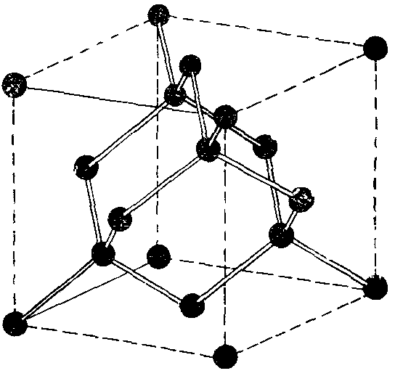
Exact answers:
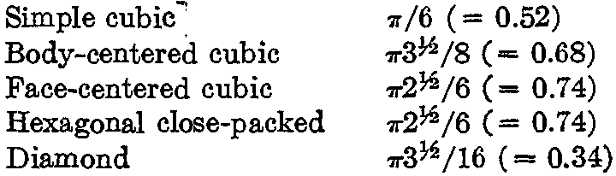

2. Prove that in a cubic crystal the direction [hkl] is perpendicular to the plane (hkl), which has the same Miller indices.

3. Tight-packed hexagonal structure, a) Show that the ratio c/a for an ideal close-packed hexagonal structure is (8/3)^{1/2} = 1.633. If c/a is significantly greater than this value, then the crystal structure can be considered as consisting of close-packed atomic planes, stacked one on top of another rather loosely. b) Show that a spatial lattice with a hexagonal close packing with a basis consisting of one atom per lattice point cannot exist.
Instructions for b): Show that it is impossible to find lattice vectors a, b, c such that a set of translation vectors T would form a lattice with hexagonal close packing. Although it is possible to choose vectors a and b, which form a hexagonal grid in the basal plane, it is impossible to construct a spatial lattice with hexagonal close packing using vector c.

4. Brillouin zone of an orthorhombic lattice. Let the orthorhombic lattice have three primitive axial vectors 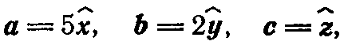
the lengths of which are expressed in angstroms. Determine (a) the reciprocal lattice vectors and (b) the dimensions and shape of the first Brillouin zone.

5. Hexagonal spatial lattice. The vectors of primitive translations of the hexagonal spatial lattice can be chosen as follows:
Find vectors of primitive translations of the reciprocal lattice. Show that the lattice is its own inverse, but with rotation of the axes. What is the angle of this rotation?

6. Structure factor of a face-centered lattice. The basis contains 4 atoms.
a) Find the structure factor of this basis.
b) Find the indices of allowed reflections from the fcc lattice.

7*. Diamond structure factor. The crystal structure of diamond is described in the problem 1. If the unit cell is an ordinary cube, then the basis contains eight atoms.
a) Find the structure factor of this basis.
b) Show that the indices of reflections allowed for the diamond structure satisfy the equality h + k + l = 4n, where all indices are even integers and n is an arbitrary integer.

Section 2: Theory of elasticity and interatomic interactions.
8. Madelung's constant. What is Madelung's constant and why is it needed? Calculate the Madelung constant for an infinite chain of ions of opposite sign: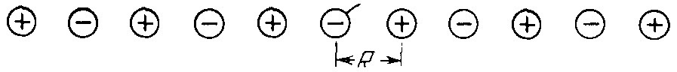
9.
10.
Section 3: Phonons.
11.
12.
Section 4: Thermal properties of the lattice.
13.
14.
Section 5. Magnetism:
15. What is the difference between the derivation and the result of the formula for the magnetization of N spins 1/2 with a magnetic moment μ in a magnetic field B according to classical physics (Langevin’s formula) and quantum physics [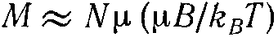]?
16. Find the contribution to the heat capacity from N spins 1/2 with magnetic moment μ in magnetic field B. Find the asymptotic behavior of this contribution within the limits of high and low temperatures.
17. Find the contribution to the heat capacity from magnons in ferromagnets and antiferromagnets. Compare the result with the contribution from phonons.

Section 6: Dispersion Law and Fermi Surface
18. Find the electron dispersion law ε(k) in metals in the tight-binding approximation for
a) cubic body-centered lattice
b) cubic face-centered lattice
c)* graphene-type lattices.
Hint: use the following formula from Kittel’s book (m – nearest neighbors):
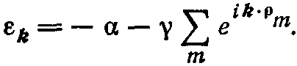
19. Determine the Fermi surface
a) for a simple square lattice in a two-dimensional metal in the weak-binding approximation, if there is 1 electron per unit cell (monovalent atom). Hint: the volume of the filled phase space coincides with the volume of the first Brillouin zone.
Generalize the method and result to the three-dimensional case of a simple cubic lattice, also with one electron per unit cell.
b) a quasi-two-dimensional metal, for which the weak coupling approximation works well in the x-y plane, and the strong coupling approximation works well along the z axis.
c) a quasi-one-dimensional metal, for which the weak bond approximation works well along the x axis, and the strong bond approximation works well along the y-z plane.

Section 7: Thermal and kinetic properties of metals
1. Find the temperature dependence of the heat capacity in a quasi-one-dimensional and quasi-two-dimensional metal. How do they differ from the case of 3D metal?
2. In the τ-approximation, find the conductivity and thermal conductivity in a quasi-one-dimensional and quasi-two-dimensional metal. How do they differ from the case of 3D metal?
Hint for problems 1 and 2: repeat step by step a similar conclusion from the lectures for a three-dimensional metal, and find where (if) there are differences.

